SIMATS ENGINEERING
ASSESSMENT TOOL 1: Agent Design Assessment
COURSE NAME: ARTIFICIAL INTELLIGENCE COURSE CODE: MLA0104
AND EXPERT SYSTEMS

COURSE OUTCOME COVERED

CO1: Apply search algorithms and heuristic techniques to solve state-space search and optimization problems. (BTL 3)

Assessment Tool Weightage: 55 %

Total Marks: 50 Time: 60 Mins
No. of Questions: 1
Annexure A
Agent Design Assessment

Code of Conduct:

I P Dinesh Reddy / 192525399 (Name / Reg No) certify that this submission is my original work and that I have adhered to the guidelines specified for this assessment. I understand that any violation of academic integrity rules will result in disciplinary action.

Signature of the student:

Question | Problem  Understanding  & AI Concept Identification | Dialogflow Agent Design &  Implementation | Problem  Formulation  &  Conversation  Flow Design | Application of  AI Techniques  & Reasoning | Testing,  Evaluation &  Documentation | Total
Weightage | 20% | 30% | 20% | 20% | 10% | 100%
Q1

Signature of the Faculty Total Marks Awarded

Scenario
A university wants to develop an AI-based Student Support Assistant to provide instant responses to student queries related to course registration, timetable, examination schedules, attendance details, and campus services.
As an AI developer, design and implement a conversational agent using Dialogflow that can understand user requests, process intents, and provide appropriate responses.

Q. No. | Criteria to be evaluated | BL | Marks
1 | Problem Analysis and Agent Design: Analyze the student support problem and explain how Artificial Intelligence can solve the problem. Design the conversational agent by defining its objective, users, environment, inputs, outputs, and expected performance measures. | BL3 | 10
2 | Dialogflow Agent Development: Create a Dialogflow agent by designing appropriate Intents, Entities, Training Phrases, Responses, and Contexts. Explain how the agent perceives user queries and generates responses. Provide screenshots of the implementation. | BL5 | 10
3 | Problem Formulation and Decision Flow: Represent the chatbot interaction as a problem-solving process by defining the initial state, user goal, possible actions, state transitions, and goal completion conditions. Draw the conversation flow diagram. | BL6 | 10
4 | Search Strategy Application: Analyze how search techniques used in AI problem solving can support conversational agents. Apply a suitable search approach (such as Breadth First Search or heuristic-based search) to model intent selection or dialogue navigation and justify your choice. | BL5 | 10
5 | Testing and Evaluation: Test the Dialogflow agent with different user queries. Evaluate accuracy, response quality, handling of unknown queries, and suggest improvements. | BL6 | 10

AI-Based Student Support Assistant using Dialogflow

Dialogflow Agent Development

Introduction
A Student Support Assistant chatbot is designed using Dialogflow to provide instant responses to student queries related to course registration, class timetable, examination schedule, attendance details, and campus services. The chatbot uses Natural Language Processing (NLP) to understand user queries, identify the correct intent, and provide appropriate responses. This reduces the workload on university staff and provides students with quick access to information.

Agent Details

Parameter | Value
Agent Name | Student Support Assistant
Platform | Dialogflow
Language | English
Purpose | Answer student queries related to course registration, timetable, examination schedule, attendance, and campus service

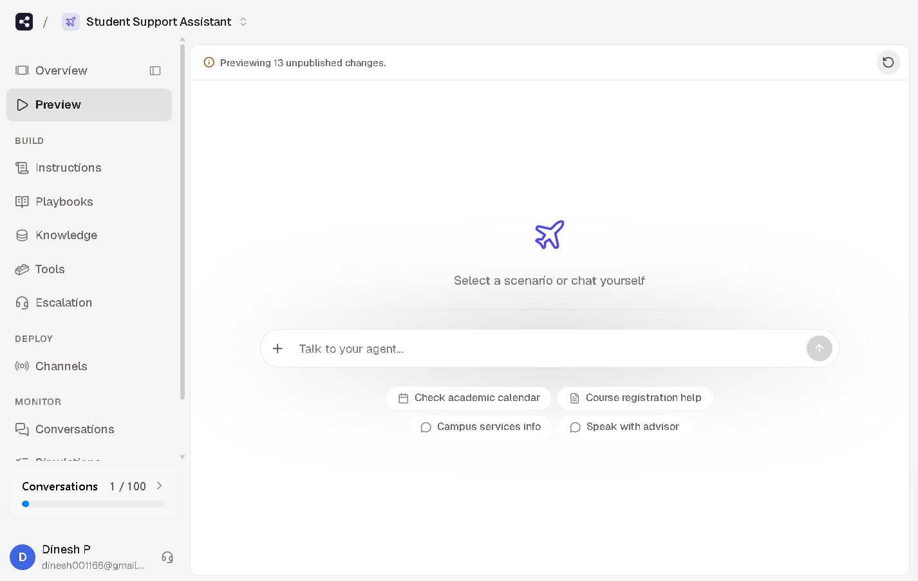
Intents
An intent represents the purpose of a user's query. The Student Support Assistant uses multiple intents to identify the user's request and provide an appropriate response.

Intent Name | Purpose
Default Welcome Intent | Greets the user and introduces the chatbot.
Course Registration | Provides information about the course registration process.
Timetable | Answers queries related to class schedules and timetables.
Examination Schedule | Provides examination dates and schedule information.
Attendance Details | Responds to attendance-related queries.
Campus Services | Provides information about library, hostel, transport, and other campus facilities.
Default Fallback Intent | Handles unknown or unsupported queries and asks the user to rephrase the question.

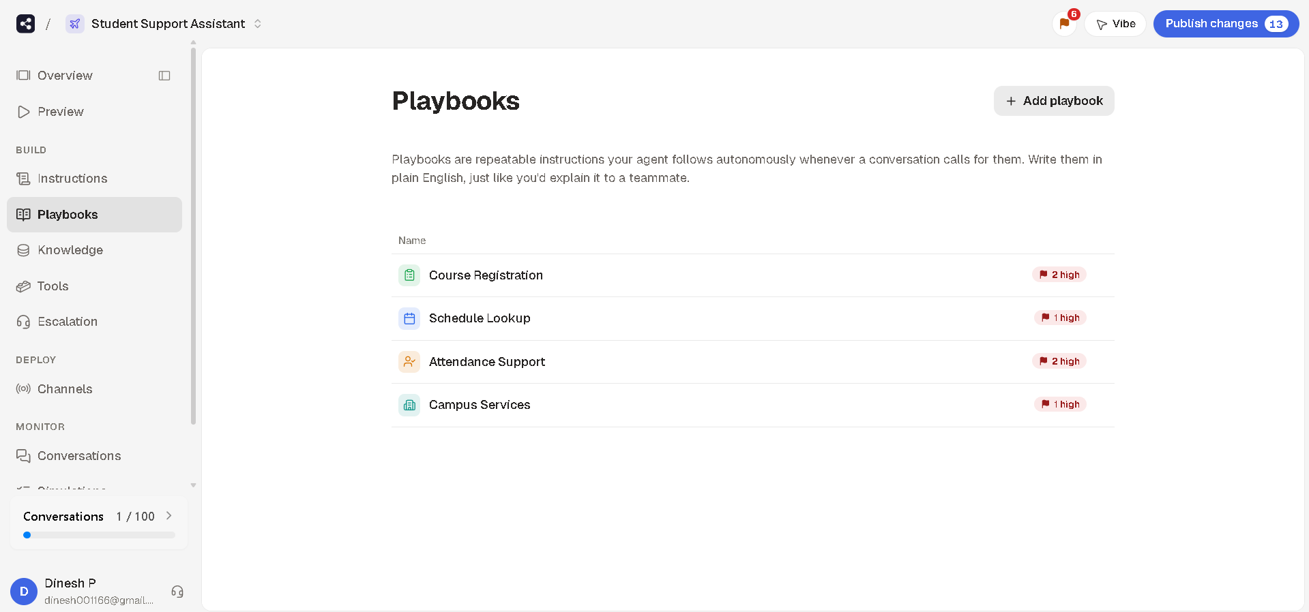

Entities

Entities are used to identify and extract important information from the user's query. They help the chatbot understand specific values such as course names, semesters, or campus services, enabling it to provide more accurate responses.

Entity Name | Sample Values | Purpose
@course | Artificial Intelligence, Data Structures, DBMS, Operating Systems | Identifies the course mentioned by the user.
@semester | Semester 1, Semester 2, Semester 3, Semester 4 | Identifies the student's semester.
@service | Library, Hostel, Transport, Cafeteria | Identifies the campus service requested by the user.
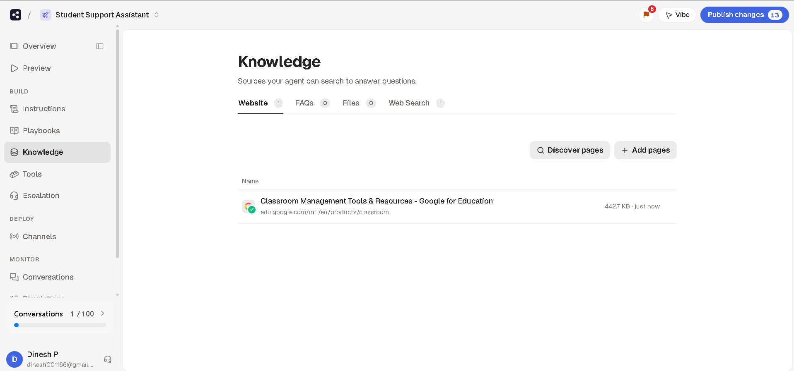

Training Phrases and Responses

Training phrases are example user inputs that help the chatbot recognize a user's intent. When a user's query matches one of these phrases or a similar variation, the chatbot triggers the corresponding intent and provides the predefined response.

Intent | Sample Training Phrases | Response
Course Registration | "How do I register for a course?", "Course registration", "Register for AI" | "Course registration can be completed through the University Student Portal. Log in with your student credentials, select your semester, choose the required courses, and submit your registration before the deadline."
Timetable | "Show my timetable", "Class schedule", "Today's timetable" | "Your class timetable is available on the student portal. Please select your semester to view the latest schedule."
Examination Schedule | "Exam timetable", "When is my next exam?", "Exam dates" | "The examination schedule is available in the Examination section of the university portal."
Attendance Details | "My attendance", "Attendance percentage", "Show attendance" | "Your attendance details can be viewed through the student information system after logging in."
Campus Services | "Library timings", "Hostel office", "Transport services" | "Campus services include the library, hostel, transport office, medical centre, and cafeteria. Please specify the service you need."
Default Welcome Intent | "Hello", "Hi", "Good morning" | "Welcome to the Student Support Assistant. How may I assist you today?"
Default Fallback Intent | Unrecognized query | "Sorry, I couldn't understand your request. Please rephrase your question or contact the university administration for further assistance."

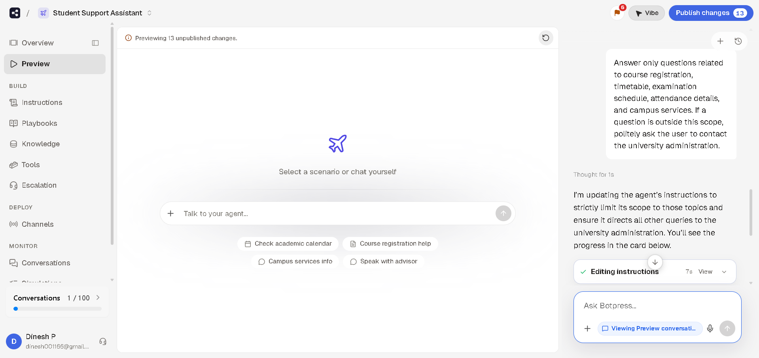

Contexts
Contexts are used to maintain the flow of a conversation by preserving relevant information between user interactions. They help the chatbot understand follow-up questions and provide responses based on the current conversation.
For the Student Support Assistant, contexts are configured as follows:

Context Name | Purpose
course-registration-followup | Maintains the conversation when the user asks additional questions about course registration.
timetable-followup | Allows the chatbot to continue answering timetable-related queries.
exam-followup | Handles follow-up questions about examination schedules.
attendance-followup | Maintains the conversation for attendance-related enquiries.
campus-services-followup | Continues the conversation when the user requests additional campus service information.

Using contexts enables the chatbot to provide more natural and meaningful conversations without requiring the user to repeat information.

How the Agent Processes User Queries
The Student Support Assistant processes user queries through a sequence of steps to provide accurate and relevant responses.
- User Query: The student enters a question in natural language, such as "Show my timetable" or "How do I register for a course?".
- Intent Recognition: Dialogflow analyzes the user's input and matches it with the most appropriate intent using the configured training phrases.
- Entity Extraction: If the query contains specific information such as a course name or campus service, the corresponding entity is identified and extracted.
- Response Generation: After identifying the intent and any required entities, the chatbot retrieves the predefined response associated with that intent.
- Fallback Handling: If the chatbot cannot identify the user's intent with sufficient confidence, it activates the Default Fallback Intent and requests the user to rephrase the query.
This process enables the chatbot to provide fast, accurate, and consistent responses to common student enquiries.

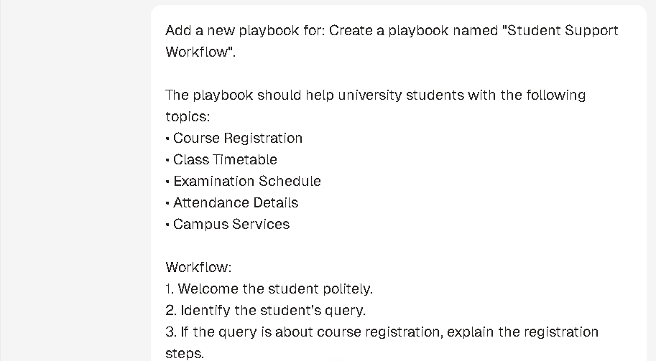
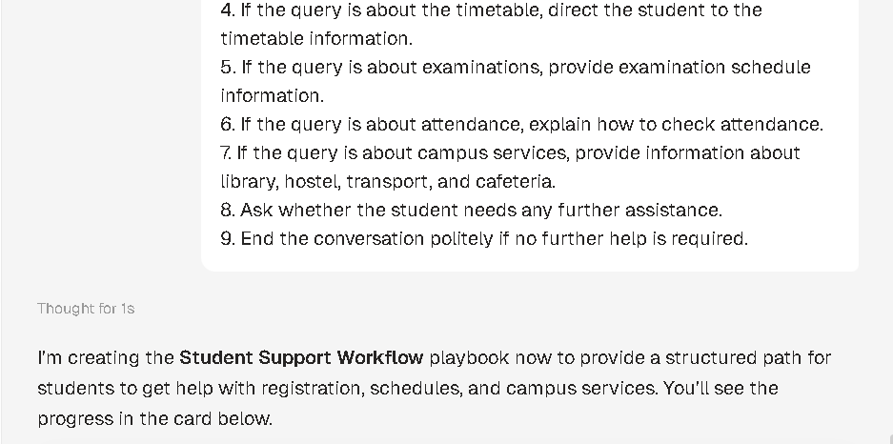
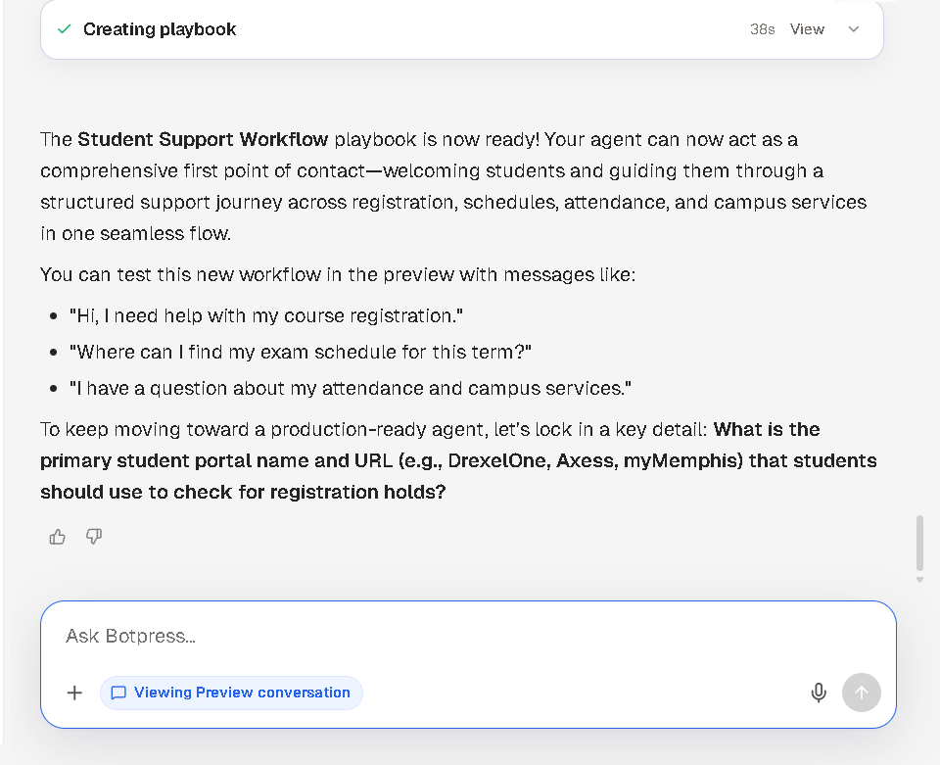

Query Processing Flow
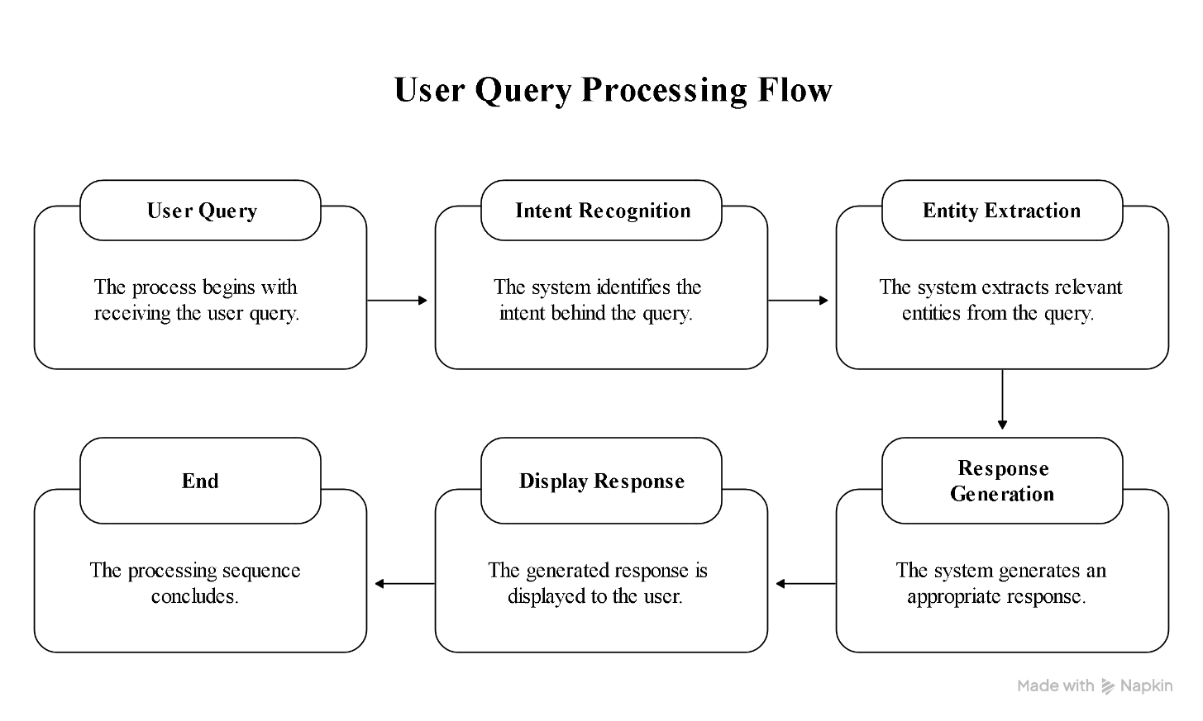

System Architecture

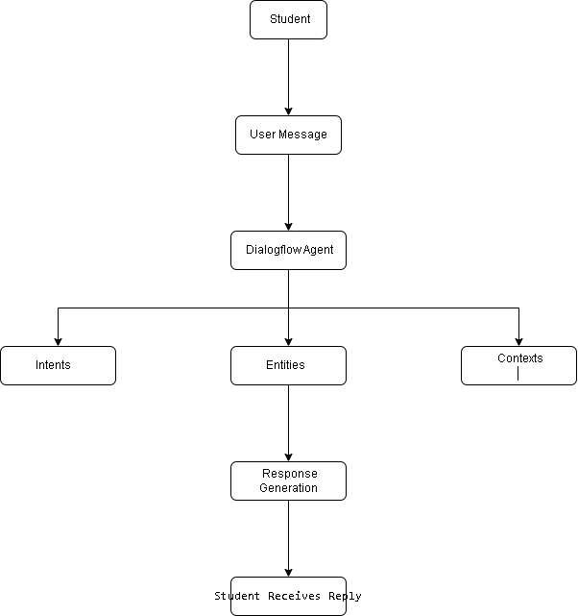
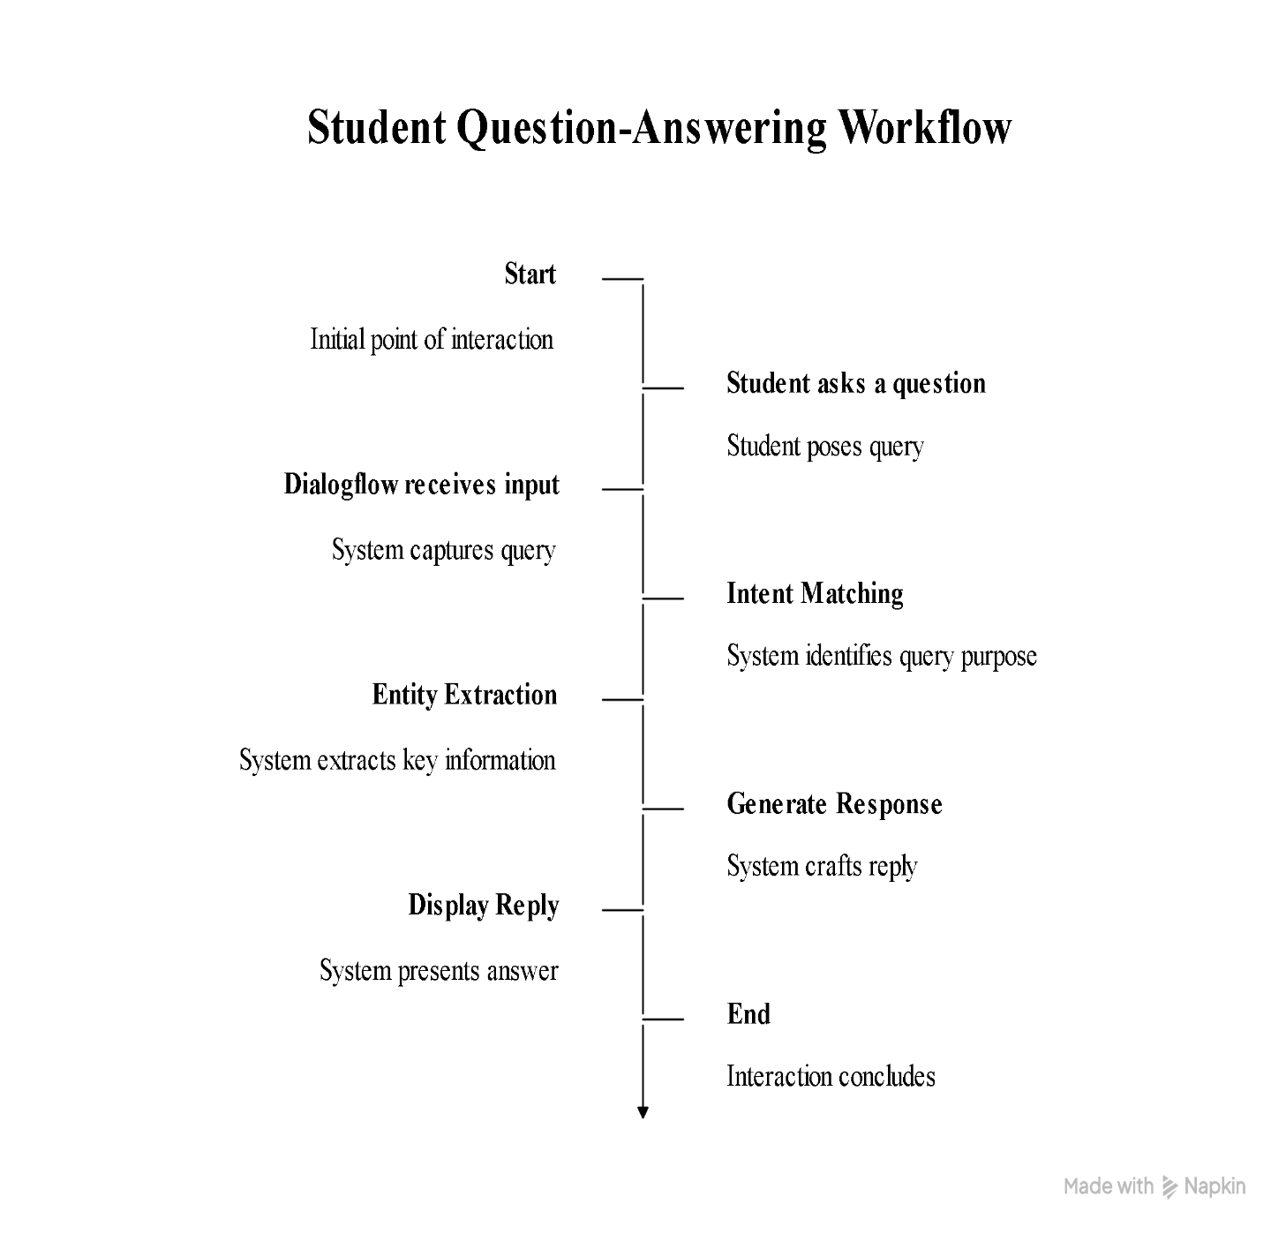

Chatbot Testing

Chatbot testing was conducted in the Botpress Preview environment to verify the chatbot's functionality. Various student queries related to course registration, timetables, examinations, and campus services were tested. The chatbot successfully recognized the queries and generated appropriate responses based on the configured knowledge base and playbooks.
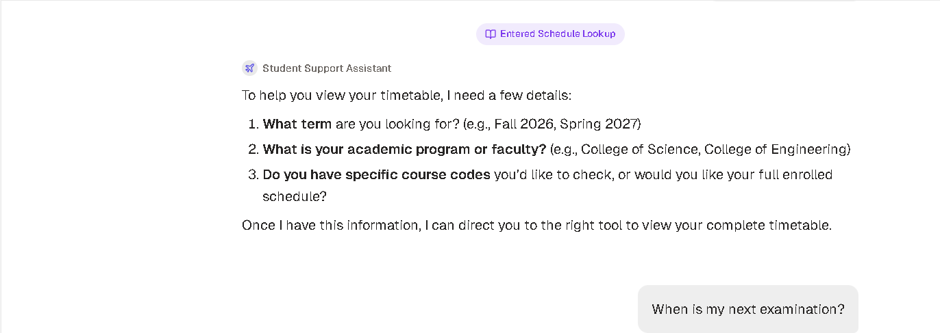
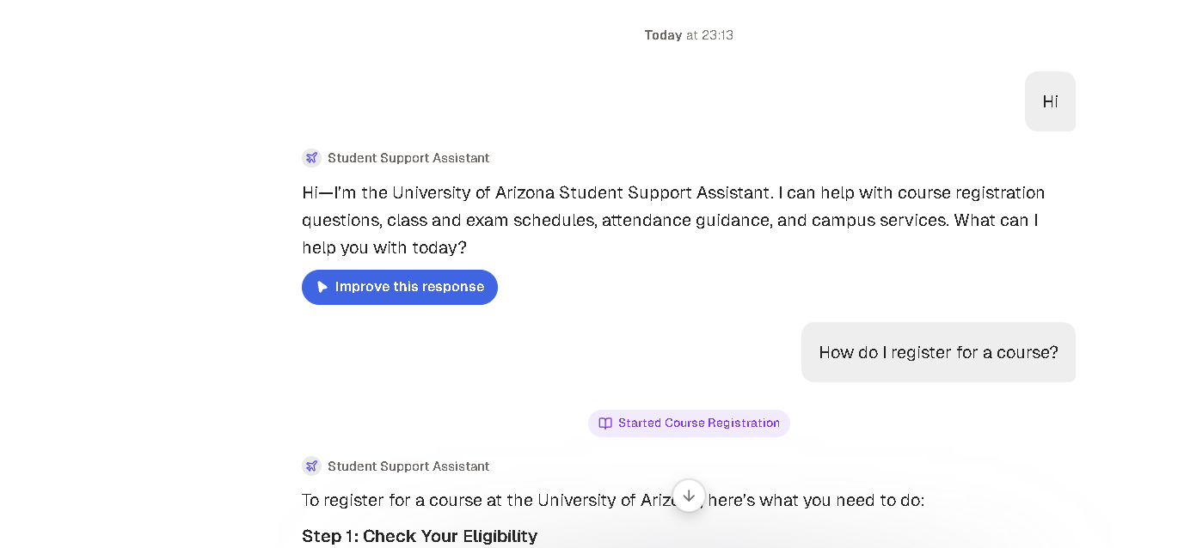
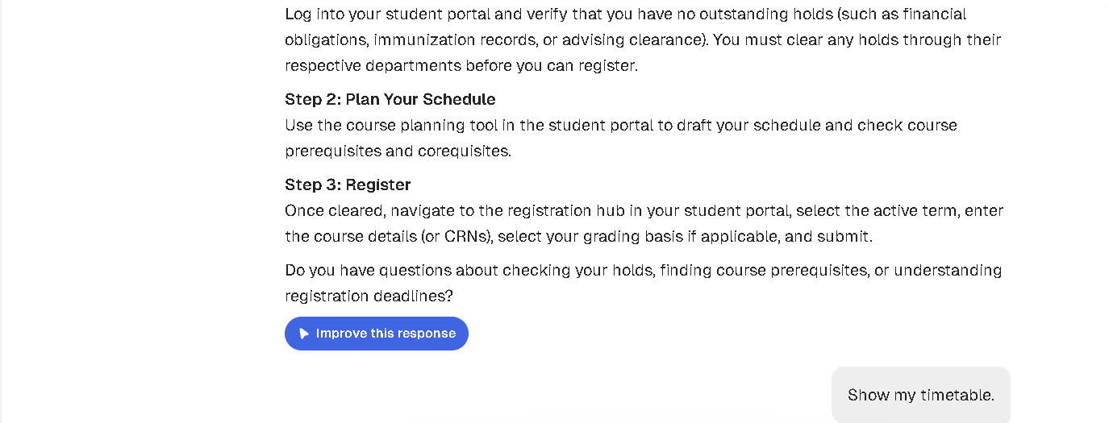
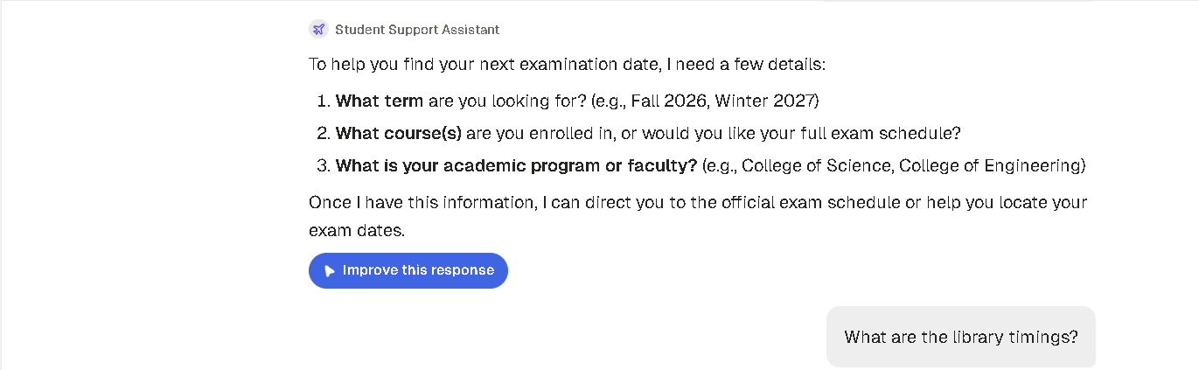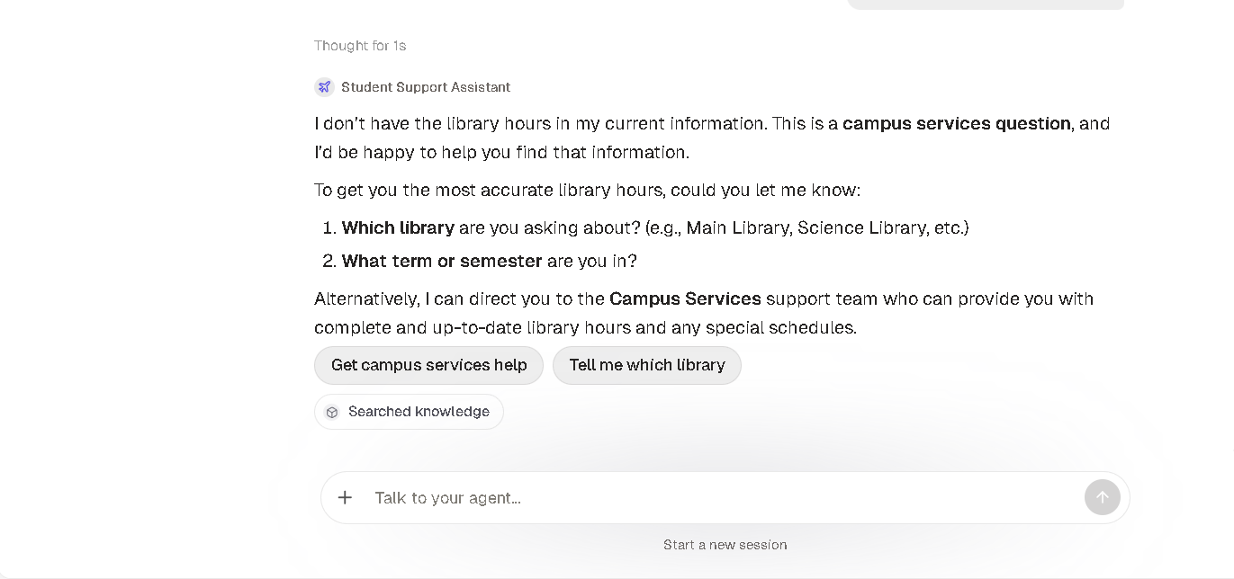

Conclusion

The Student Support Assistant was designed using Dialogflow to provide automated support for common university-related queries. The chatbot includes well-defined intents, entities, training phrases, responses, and contexts to understand user requests and deliver relevant information. The implementation demonstrates how conversational AI can improve student support by providing quick, consistent, and user-friendly assistance.

Evaluation Rubrics

Criteria | Weightage  (%) | Excellent (Full Marks) | Good | Average | Poor
Problem  Understanding &  AI Concept  Identification | 20% | 10 – Clearly analyzes the student support problem, defines AI application, agent objective, users, environment, inputs, outputs, and performance measures with proper justification. | 7.5 – Identifies most components of the agent design with minor omissions. | 5 – Provides basic problem analysis with limited explanation of agent components. | 0–2.5 – Incomplete understanding of problem and agent design.
Dialogflow Agent  Design &  Implementation | 30% | 10 – Successfully creates a functional Dialogflow agent with appropriate intents, entities, training phrases, responses, contexts, and explains interaction flow with screenshots. | 7.5 – Develops major Dialogflow components with minor configuration errors. | 5 – Creates basic intents and responses with limited entity/context utilization. | 0–2.5 – Incomplete or incorrect  Dialogflow implementation  .
Problem  Formulation &  Conversation  Flow Design | 20% | 10 – Clearly represents chatbot interaction using initial state, goal state, actions, state transitions, goal conditions, and a well-designed conversation flow diagram. | 7.5 – Provides a structured flow with minor missing details. | 5 – Provides basic flow representation with limited explanation. | 0–2.5 – Poor or missing problem formulation and decision flow.
Application of AI  Techniques &  Reasoning | 20% | 10 – Correctly analyzes and applies suitable search strategies (BFS/heuristic search) for intent selection or dialogue navigation with strong justification. | 7.5 – Applies appropriate search strategy with reasonable explanation. | 5 – Provides basic understanding of search strategy application. | 0–2.5 – Unable to relate search concepts with conversational agent.
Testing,  Evaluation &  Documentation | 10% | 10 – Performs comprehensive testing using multiple user queries, evaluates accuracy, response quality, unknown query handling, and suggests meaningful improvements. | 7.5 – Performs adequate testing and provides evaluation with minor gaps. | 5 – Conducts limited testing with basic observations. | 0–2.5 – Insufficient testing and evaluation.

